**Kubernetes Activity5- for the deployment created in Activity4, modify image to use nginx , verify the change using CLI, do a rollback and verify again.**

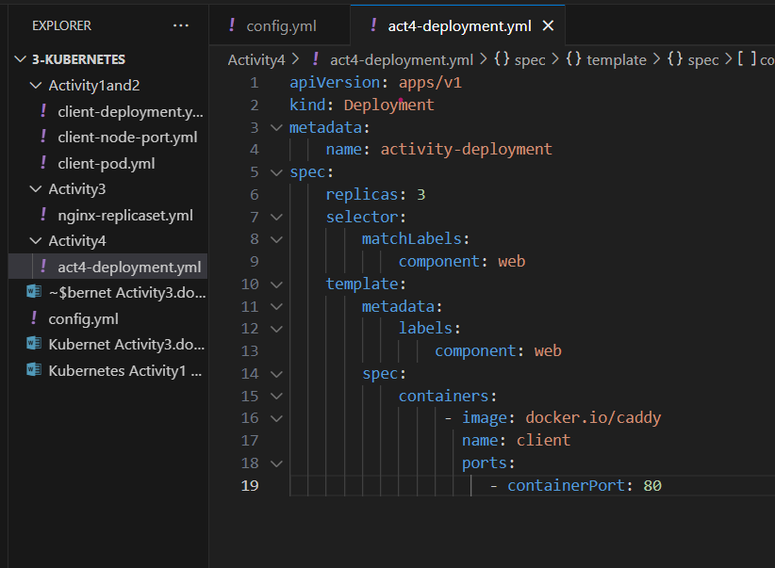

# Create a deployment that manages 3 replicas of caddy.

*$ kubectl apply -f act4-deployment.yml*

# Verify that the deployment created the pods.

*$ kubectl describe deployment activity-deployment*

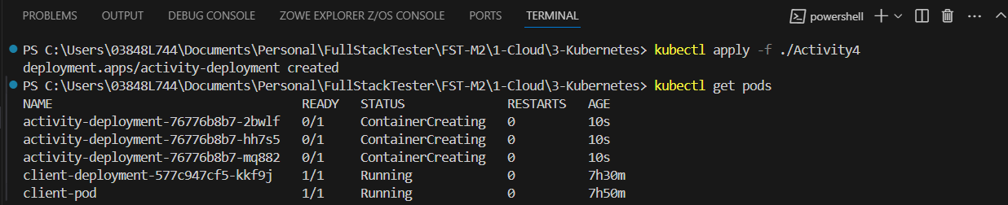

# Modify the deployment to use nginx instead of caddy. (Activity5)

*$ kubectl apply -f act4-deployment.yml*

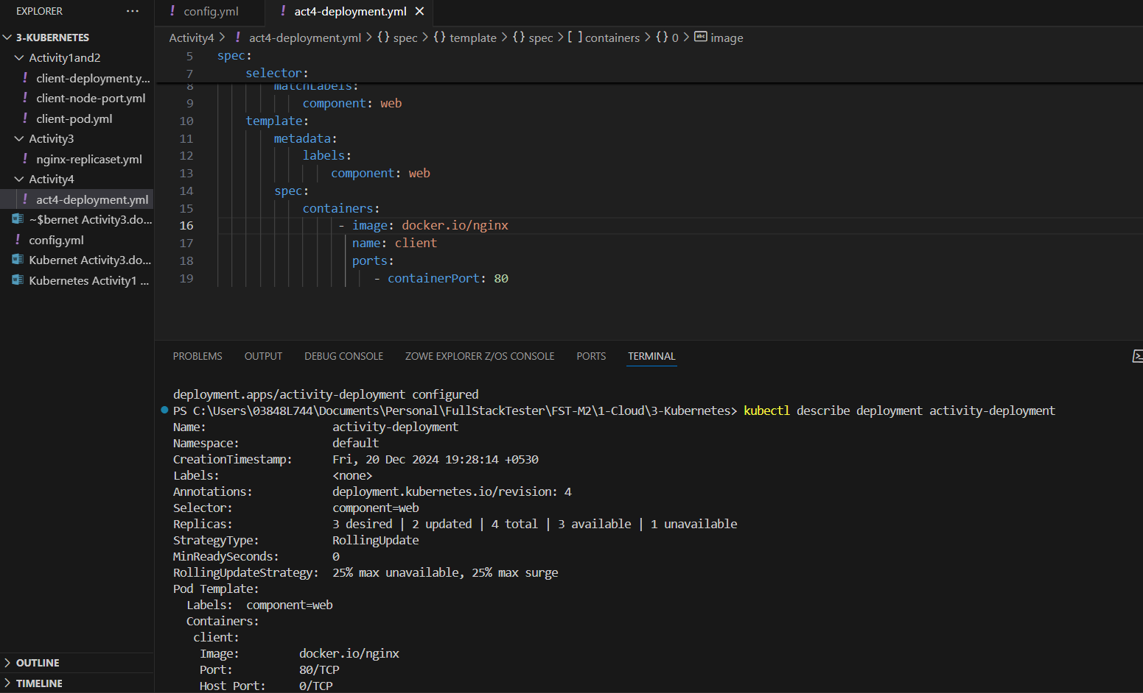

# Rollback the deployment and verify that the pods are once again running caddy.

*$ kubectl rollout undo deployments/activity-deployment*

